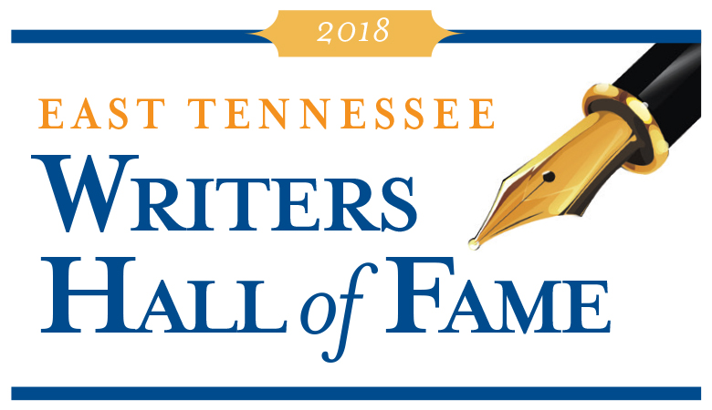

Sponsorship Opportunities

The 15th annual East Tennessee Writers Hall of Fame to benefit Friends of Literacy will be held on October 5, 2018, at 6:30 pm at Club LeConte in downtown Knoxville for over 250 guests. During the event, Friends of Literacy will induct 14 local writers into the East Tennessee Writers Hall of Fame, including the posthumous induction of six renowned writers from previous generations. Sponsors at the $5,000 and $10,000 levels will have their name on the eight awards presented to living writers.

$10,000 Presenting Sponsor
- Listed as Presenting Award Sponsor in all promotional pieces including program and invitation
- Award of choice (excluding Lifetime Achievement) named after sponsor and opportunity for a sponsor representative to present award
- Sponsor logo/name will appear in all applicable advertisements
- Name mention in all event related press releases
- Sponsor acknowledged at event
- Logo/name on signage at event
- Two tables at the awards dinner (seating for 20)

$5,000 Award Sponsor
- Listed as sponsor in all promotional pieces including program and invitation
- Chosen award named after sponsor and opportunity for a sponsor representative to present award
- Sponsor logo/name will appear in all applicable advertisements
- Name mention in all event related press releases
- Sponsor acknowledged at event
- Logo/name on signage at event
- One table at the awards dinner (seating for 10)

$2,500 Sponsor
- Listed in the program
- Sponsor acknowledged at event
- Logo/name on signage at event
- One table at the awards dinner (seating for 10)

$1,500 Table Sponsor
- Listed in the program
- One table at the awards dinner (seating for 10)

Deadline for sponsorship commitment is August 23rd.
Please contact madison@friendsofliteracy.org for more information.

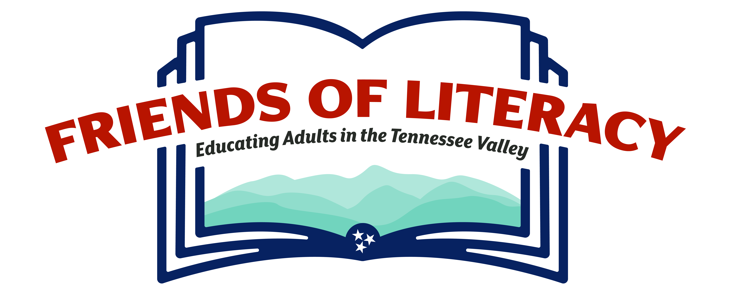

ABOUT FRIENDS OF LITERACY

Our Mission: The mission of Friends of Literacy is to provide high-quality adult education programs for those in our community who are inadequately educated to meet the challenges of daily life. Our goal is to enable our students to achieve their full potential and become better citizens.

Who We Serve: Adults who are at an eighth grade or lower level of education, who need to improve their reading, writing, and/or math abilities in order to increase their job and educational opportunities and their positive impact on society.

How We Fulfill Our Mission

Beginning Readers: For adults who cannot read. Students will work one-on-one with tutors, using the Wilson Reading System. Incoming students are assessed to determine their entry “step” and then re-assessed quarterly. Students may be native speakers of English or of another language. Students must be able to communicate verbally in English.

Adult Basic Education: Language arts and math classes for adults at an elementary level of literacy (grades 1-8). There are separate classes for each subject, as well as two levels per subject (grade level 1-4 and grade level 5-8).

HiSet Prep Classes: At Norwood Elementary school and Fountain City United Methodist Church, for adults who score higher on their initial assessments or who want to move into a HiSET program after completion of intermediate level classes. Norwood classes are in conjunction with Great Schools Partnership and are taught by FOL staff. Fountain City classes are taught by volunteers.

Tennessee Valley Reads: FOL provides training, support, and student assessment for volunteer-led beginning reader classes across the area. Churches, civic organizations, etc. conduct classes at least once per week, and they determine the day, time, and number of students. Friends of Literacy trains the volunteers, provides initial and quarterly student assessment, and tracks student progress. Wilson Reading System materials can be borrowed from FOL if the sponsoring group cannot purchase materials.

One-On-One Learning: Expanding on our current tutoring program for students in FOL classes, we offer one-on-one learning as an alternative for students whose work schedules preclude taking classes at FOL. We train the tutors, match tutors with students, provide instructional materials, and assess the students. The students and tutors are responsible for coordinating mutually-agreeable study times, always in public places.

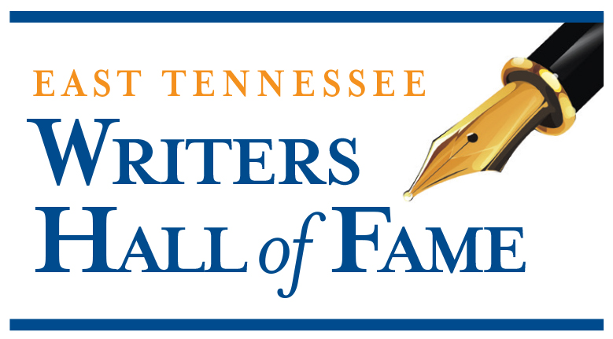

ABOUT EAST TENNESSEE
WRITERS HALL OF FAME

Friends of Literacy recognizes the importance of authors’ contributions to our culture and history. Through the Writers Hall of Fame, we honor those who entertain, inspire, and inform us through the written word. Nominations are accepted in eight categories: Fiction, Poetry, Social Media, Non-Fiction, Children’s Literature, Drama, Song Writing, and Lifetime Achievement. An independent panel of judges evaluates the nominees based on recognition within the writer’s field, longevity, quality, and volume of work. All nominees must have either been born in, currently reside in, or have a body of work related to the East Tennessee region. At the October event, writers voted on by the selection committee will be inducted into the Hall of Fame.

The work Friends of Literacy does to educate adults in our community would not be possible without our caring and committed donors and sponsors. Please consider a Hall of Fame sponsorship so you can help us eradicate adult illiteracy in our area, while also honoring the best writers in East Tennessee.

